DA (Door Access) Encoder Procedures

Log In

- To log in, swipe the Res Life log in card with the mag stripe facing out / away from you.

NOTE: This is NOT the user ID card to be updated

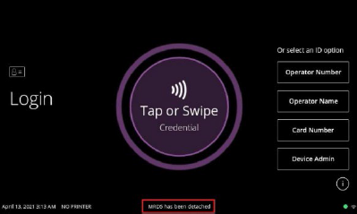

- After Success message, Enter PIN code and click OK
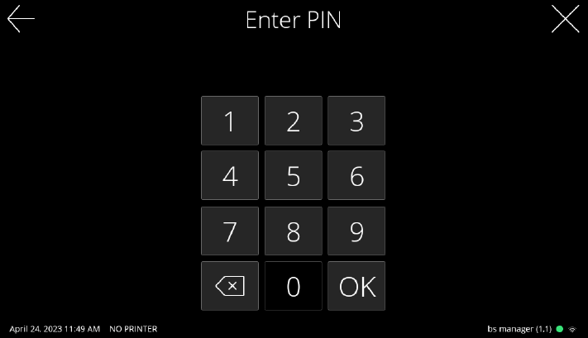

Check for DA Sector Encoding

- After a successful login, two tiles will be displayed:
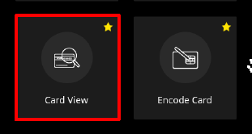

- Select the Card View tile to view the current user ID card details
- At the Card View screen, select the Full Read Mode button

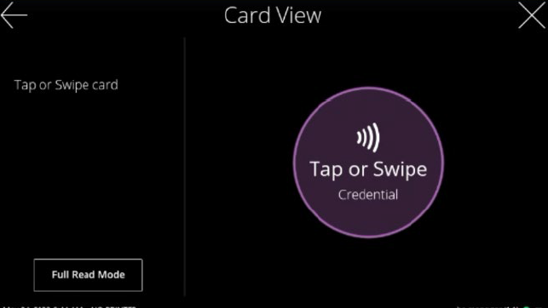

- Place card on the Tap or Swipe Credential circle and hold it there
- The Full Read Report screen is displayed

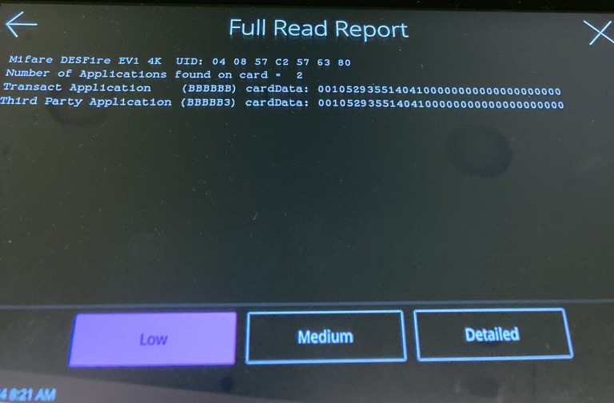

- Check for the DA sector encoding. If you only see a Transact Application and a Third Party Application row, the card needs to be updated.
- Select X or the back arrow to return to the main screen (the screen with the two tiles)

Encode Card

The Encode Card option allows you to encode a Door Access (DA) sector by copying data from a swiped card. The Door Access sector information is required for automatic / lobby doors to work.
- Select X in the upper-right of the screen until the main Transact screen is displayed

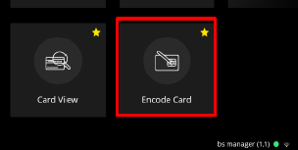

- Select the Encode Card tile
- The Encode Card screen displays
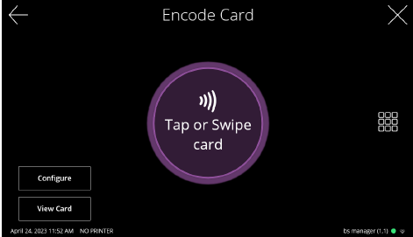

- Swipe the ID card to be updated with the mag stripe facing away from you
- Place card on the Hold Card Here circle and hold it there

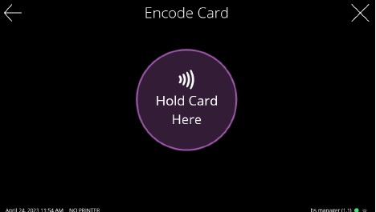

NOTE: you may have to readjust the placement of the card slightly

- The Success screen displays briefly
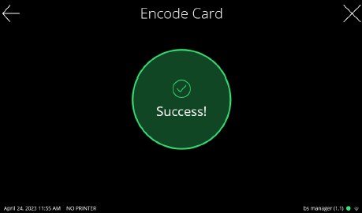

Verify Door Access (DA) Encoding

- Select X or the back arrow to return to the main screen
- Following the procedures to perform a Full Read on the card
- At the Full Read Report screen, you should now see a Transact Application row, a Third Party Application row, and a Door Access Application row.

